SOFTWARE ENGINEERING LAB
Twinkle Ghodki
23BCE1977

BCSE301L
Week - 2: Agile Process Model

- AGILE PROCESS MODEL
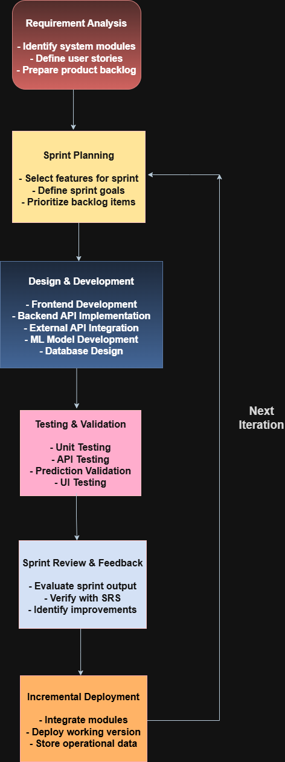
draw.io link –
https://app.diagrams.net/#G1ZslnSkosQM060Z5b2SUVpZ9R84o-Xosq#%7B%22pageId%22%3A%22LddF6A8e00D604S9gDYP%22%7D

